MINUTES OF THE
Mississippi Electronic Government Oversight Committee
June 17, 2025

COMMITTEE MEMBERS PRESENT:
MS Department of Information Technology Services Stephanie Hedgepeth, Chair
MS Department of Finance and Administration Gilda Reyes
MS Department of Revenue Mickey Yates
MS Office of the Secretary of State Daniel Jordan, Vice-Chair
MS Office of the State Auditor Tom Chain

OTHERS PRESENT:
MS Department of Information Technology Services Amber Dupree
MS Department of Information Technology Services Matthew Henry
MS Department of Information Technology Services Renee Murray
MS Department of Information Technology Services Steve Patterson
MS Office of the Attorney General William Collins
MS Office of the State Treasurer Kurt Turner
MS Department of Wildlife, Fisheries and Parks Brian Ferguson
MS Department of Wildlife, Fisheries and Parks Jason Thompson
Tyler Thomas Allen
Tyler David Campbell
Tyler Amanda Green
Tyler Raghul Manoharan
Tyler Tina Wells

Ms. Stephanie Hedgepeth called the meeting to order.

Ms. Stephanie Hedgepeth called for a motion to approve the minutes of the April 15, 2025 meeting, April 30, 2025 and May 20, 2025 Special Called Meetings if no changes were needed. Mr. Mickey Yates made the motion to accept the minutes as presented. The motion was seconded by Mr. Daniel Jordan and passed with none opposed.
Mr. Brian Ferguson with the Mississippi Department of Wildlife, Fisheries and Parks provided an update for the request to extend the temporary waiver of the EOC fee for their new parks and reservation system through July 31, 2025. Mr. Daniel Jordan made the motion to accept the minutes as presented. The motion was seconded by Mr. Mickey Yates and passed with one opposed.

Ms. Gilda Reyes asked MDWFP for a project status update on the payment processor for the Hunt/Fish licenses. According to Brian Ferguson there is no update currently.

Ms. Tina Wells presented the Portal Highlights and Current Projects portion of the EOC reports:
Mississippi Department of Marine Resources Recreational Licensing
- Configurable and User-Friendly Licensing Portal that ensures anyone can sign up or renew their licenses
- Flexibility that allows for online and retail license sales
- Real-time data visualization and reporting for improved data management

Mississippi Charter School Authorizer Board Website
The features to this website include:
- Engaging user experience
- Clear presentation of schools, resources, and application processes
- Customized branding and cohesive layout

April 2025 breaks the payment processing record with a 34% growth rate and 33.2 million processed.

Animal Control Permit Application
Platform modernization to simplify workflows and improve data accessibility.

Mississippi State Fire Academy
Tyler created a point-of-sale system for the Mississippi State Fire Academy.

Communicator Awards of Distinction
- Mississippi Board of Pharmacy Prescription Monitoring Program Website
- Mississippi Department of Rehabilitation Services Website
- Mississippi Office of the State Auditor Website
- Pearl River Valley Water Supply District Website

Mississippi Department of Health
Tyler developed a Radiological Health OntheGo Inspection Platform for the Mississippi Department of Health.

Institutions of Higher Learning
Tyler redesigned IHL’s website with improved functionality tailored to serve Mississippians and visitors better. The new features give cleaner navigation with new branding. Fully responsive and it looks great on any screen size. Built with accessibility tools & transparency in mind.

Ms. Wells presented the fiscal reports covering activities since the last meeting and fiscal year-to-date transactional metrics.

Ms. Wells discussed the status of projects in development and presented the following projects for Prioritization Approval:

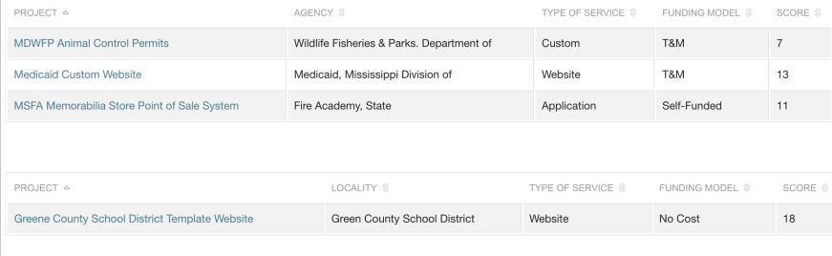
Ms. Stephanie Hedgepeth entertained a motion to approve the project queue. Mr. Daniel Jordan moved that the projects presented for prioritization and approval be approved. The motion was seconded by Mr. Mickey Yates. The motion passed with none opposed.

Ms. Tina Wells presented the overview of the Government Experience Award Submission and nomination focus areas.
- Customer experience channels, engagement strategies and significant citizen accomplishments​
- Accessibility​
- Artificial Intelligence
- Future Priorities
Mr. David Campbell gave an overview of the Portal Security and Infrastructure
Uptime Report
- Last 3 Months – 99.76%
- Since 01/01/2025 – 99.84%
- FYTD – 99.91%
Infrastructure Cloud Migration
- Started migrating first application to AWS Sandbox
- Working with ITS on requirements for AWS Landing Zone to ensure compatibility with State Network
- Meeting with Tyler CMS Centers of Excellence team to determine best fit and options for Drupal Hosting
Scheduled Maintenance
Production
- Enterprise application updates first maintenance window each month
- Infrastructure Upgrades and Maintenance second maintenance window of the month.
- Security patching for Windows and Linux third maintenance window of the month.
Lower Environments
- (Development, Test, and User Acceptance Testing)
- Security patching for Windows and Linux are completed one to two weeks prior to Production Security patching.
Security
- Up to date with Windows and Linux Patching.
- Annual Holistic Pentest Scheduled for Q3
- Tyler's Security and Compliance Assessment Program is reviewed by TrustWave.
- The Assessment period is April 1st through March 31st annually.
Mr. Campbell presented the latest PCI Compliance Program update.
- PCI DSS 4.0 became effective April 1, 2024.
- Requirement to scan applications connecting to CCP.
- Scans must be performed quarterly
Ms. Hedgepeth reviewed the Meeting Schedule for FY 2026.

The next meeting is scheduled for August 19, 2025. Ms. Stephanie Hedgepeth entertained a motion to approve the FY2026 Meeting Schedule. Mr. Mickey Yates made a motion to approve schedule as is with no edits. The motion was seconded by Mr. Daniel Jordan. The motion passed with none opposed.

Ms. Daniel Jordan made a motion that the meeting be adjourned. Mr. Mickey Yates seconded, and the motion was approved with none opposed. The meeting was adjourned.

_________________________________ ___________________________________

Stephanie Hedgepeth, Chair Daniel Jordan, Vice-Chair

